HYPERTRACK
Hyperhidrosis Monitoring and Management System
PROJECT PROPOSAL | COURSE UCS503
Submitted to: Dr. Jeelani Asif
Submitted by
Aditya Rajput (1024240145) · AIML
Prabhkirat Kaur (1024240024) · AIML
August 2026

Executive Overview
HyperTrack is a proposed web-based monitoring and management system for recording, organizing, visualizing, and analyzing user-reported sweating episodes associated with hyperhidrosis. It is designed primarily as a Software Engineering project, with an optional AIML component for personalized pattern analysis and severity prediction. The system does not diagnose or treat hyperhidrosis; it helps users organize their own data and generate reports that can support conversations with healthcare professionals.

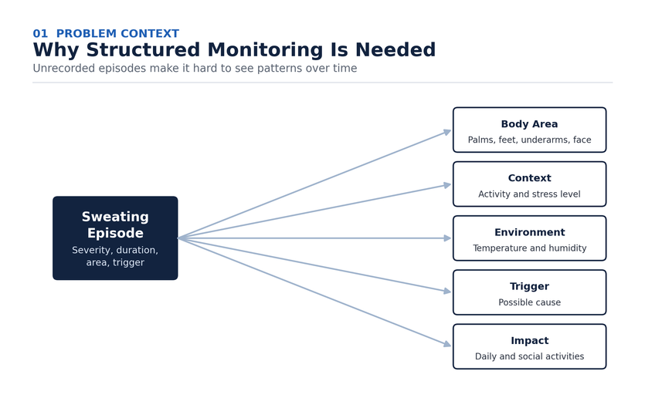
Figure 1. Problem context and motivation for structured monitoring.
1. Problem Statement
Hyperhidrosis involves excessive sweating beyond normal temperature regulation, often affecting the palms, feet, underarms, and face. A key challenge is the lack of consistent records covering severity, duration, affected area, triggers, activity, and stress. HyperTrack addresses this gap by converting individual episodes into structured records that can be analyzed over time to reveal patterns that would otherwise be missed.
2. Objectives
The project aims to build a reliable, user-friendly system for recording and analyzing sweating episodes. Specific objectives include:
- Provide a user-friendly interface for recording episodes and associated context.
- Store symptom records in a structured, secure database.
- Analyze frequency, severity, duration, affected body areas, and possible triggers.
- Deliver dashboards with graphs, statistics, and historical trends.
- Support treatment/session tracking without issuing medical prescriptions.
- Generate an organized report summarizing recorded history.
- Investigate machine learning for personalized severity prediction.
- Apply sound Software Engineering practice across the development lifecycle.
3. Proposed Solution
HyperTrack is proposed as a web application comprising user management, episode recording, structured data storage, an analytics module, an interactive dashboard, treatment/session tracking, report generation, and an optional machine learning module. The system is positioned as a monitoring and decision-support tool rather than a diagnostic system.

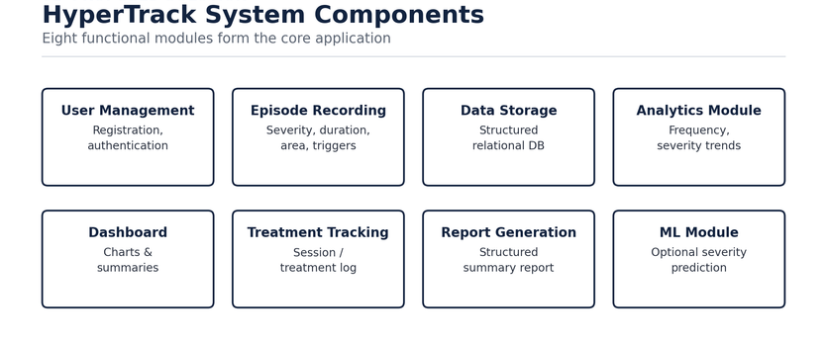
Figure 2. Eight functional modules forming the core application.
4. System Architecture
The application follows a three-tier architecture. The presentation layer (HTML, CSS, JavaScript) delivers the user interface; the application layer (Python and Flask) exposes REST APIs and hosts analytics and machine learning services; and the data layer (MySQL) stores users, episodes, triggers, and treatment records. This separation keeps the system easier to test, maintain, and scale.

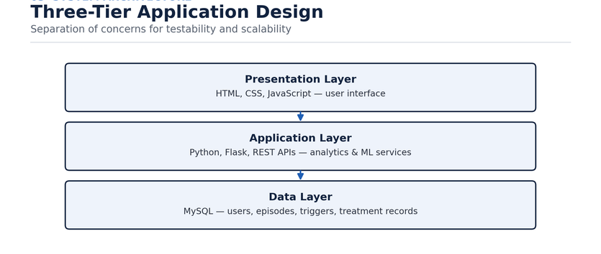
Figure 3. Three-tier architecture with analytics and ML services.
5. System Workflow
The core workflow begins with user login, followed by episode recording, input validation, and database storage. Historical records then pass through the analytics module to populate the dashboard, after which the optional machine learning module can add a severity insight before the user generates a structured monitoring report.

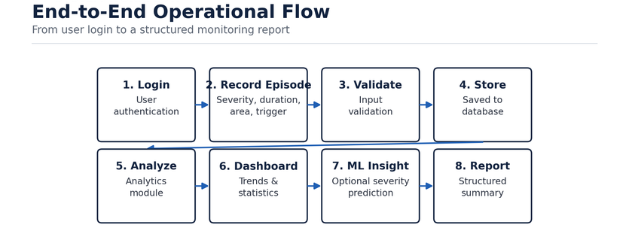
Figure 4. End-to-end operational workflow.
6. Episode Data Collection
Each recorded episode captures the date and time, sweating severity, duration, affected body area, activity, self-reported stress level, possible trigger, temperature and humidity where available, and any additional notes. This structured record forms the basis for both statistical analysis and future machine learning functionality.

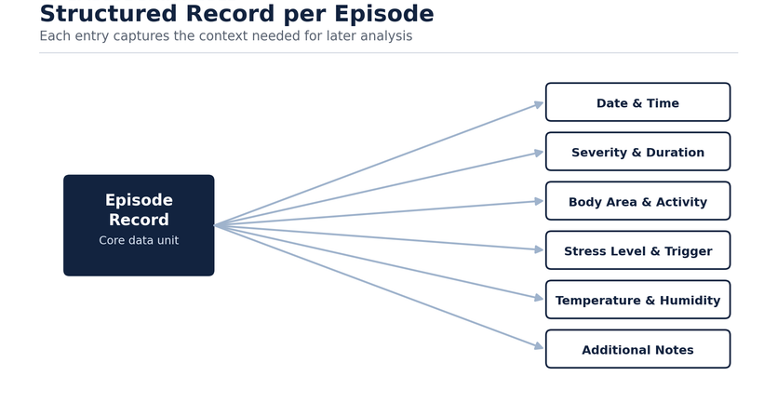
Figure 5. Structured data captured for each episode.
7. Data Processing and Analytics
Stored records are cleaned and processed to calculate daily and weekly frequency, average severity, average duration, frequently affected areas, commonly recorded triggers, severity trends, and associations between stress and severity. Results are presented as patterns or associations in the user's recorded data rather than medical conclusions.

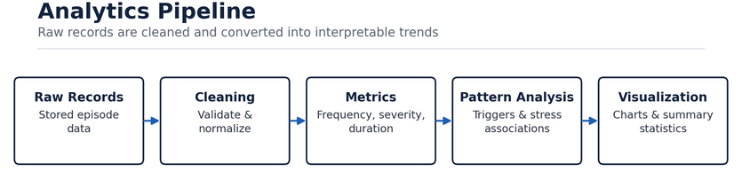
Figure 6. Analytics pipeline and derived metrics.
8. Machine Learning Component
As the AIML component, the project investigates supervised severity classification using features such as stress, temperature, humidity, activity, time of day, previous severity, duration, caffeine intake, and affected body area. Candidate algorithms include Logistic Regression, Decision Trees, and Random Forest, with Random Forest considered the initial model for its ability to handle multiple features and report feature importance. The output is a severity category of Low, Moderate, or High, offered strictly as a supplementary insight.

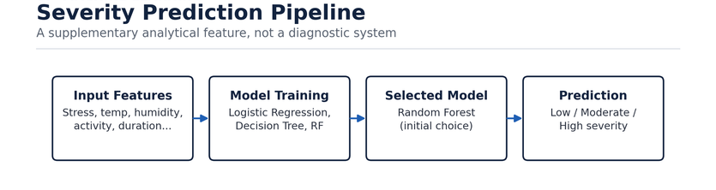
Figure 7. Proposed machine learning pipeline.
9. Testing and Validation
Testing runs throughout development. Unit testing covers individual functions such as login, episode creation, and validation; integration testing verifies communication across the frontend, backend, database, and analytics modules; system testing validates the complete workflow from login through report generation; and user acceptance testing evaluates usability and clarity with selected users. If implemented, the ML module is evaluated using accuracy, precision, recall, F1-score, and a confusion matrix.

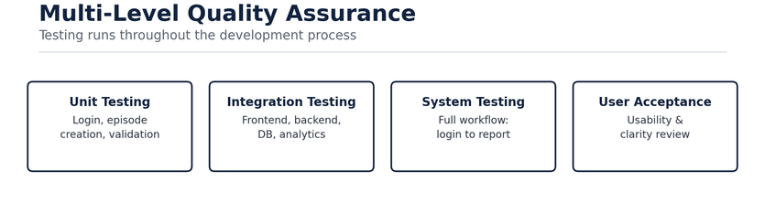
Figure 8. Multi-level testing and validation strategy.
10. Technology Stack
The proposed stack relies primarily on free and open-source technologies: HTML/CSS/JavaScript for the frontend; Python, Flask, and REST APIs for the backend; MySQL, Pandas, and NumPy for data; Scikit-learn, Chart.js, and Matplotlib for machine learning and visualization; and Git/GitHub with VS Code or PyCharm for tooling and version control.

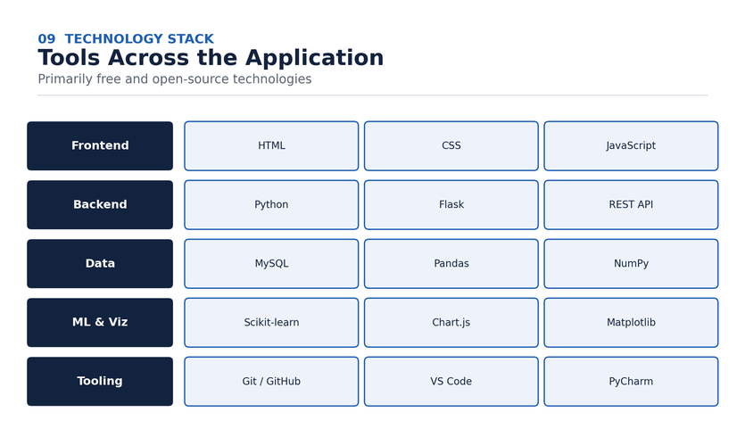
Figure 9. Technology stack across the application.
11. Development Timeline
Development spans a 15-week semester using an iterative approach, prioritizing core monitoring functionality before advanced analytics and machine learning features. A buffer period is maintained during the final development and testing stages to absorb unexpected technical issues.

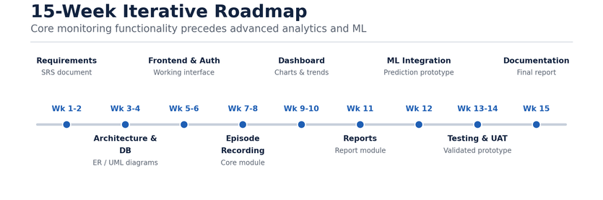
Figure 10. Semester development roadmap.
12. Resources and Budget
The project is developed by two students. Aditya Rajput (AIML) leads backend development, database integration, machine learning, and system integration. Prabhkirat Kaur (AIML) leads frontend development, UI/UX, documentation, testing, and analytics integration. Both members participate in requirements analysis, system design, testing, and final documentation.
The software stack is built entirely on freely available or open-source tools — Python, Flask, MySQL, Pandas, NumPy, Scikit-learn, HTML/CSS/JavaScript, Git/GitHub, and VS Code or PyCharm — so no external funding is required for the initial implementation. Future cloud hosting or external services, if needed, may introduce additional costs.
13. Risks and Mitigation
Key risks include limited data availability for the ML prototype, protection of sensitive health data, the possibility of medical misinterpretation, ML reliability, development delays, and user adoption. Each is addressed with a concrete mitigation strategy, summarized below.

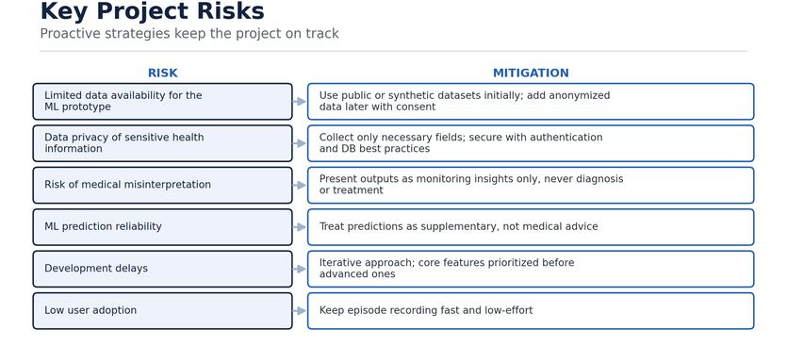
Figure 11. Key project risks and mitigation strategies.
14. Expected Outcomes
At completion, HyperTrack is expected to be a functional web application that lets users maintain structured episode records, understand frequency and severity trends, identify common triggers, track treatment history, and generate an organized monitoring report — with optional ML-based severity insight. From a Software Engineering standpoint, the project demonstrates requirements engineering, system architecture, database management, modular development, testing, and iterative delivery.

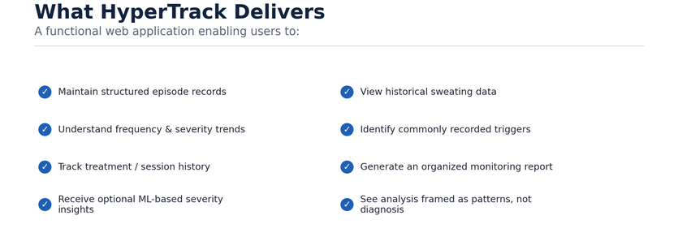
Figure 12. Expected project outcomes.
Clinical Scope Note
HyperTrack is a monitoring and decision-support system. Its analytics and ML outputs are supplementary insights drawn from user-recorded data — they are not medical diagnosis, treatment recommendations, or medical advice.
Aditya Rajput — Roll No. 1024240145 — arajput_be24@thapar.edu
Prabhkirat Kaur — Roll No. 1024240024 — pkaur2_be24@thapar.edu

